EXP NO 21: Create a SQL storage /Database and execute a basic query
AIM:
Create a SQL storage service and perform a basic query using any Public Cloud Service Provider (Azure/GCP/AWS) to demonstrate Database as a Service (DaaS) using Azure.
Procedure:
Procedure:
- Log in to Azure Portal.
- Create a SQL Database → Select Use existing data → Sample (AdventureWorksLT).
- Open Query Editor → Sign in with credentials.
- Run the SQL query to join tables SalesLT.ProductCategory and SalesLT.Product.
- View the result showing product categories and product names.
Design:
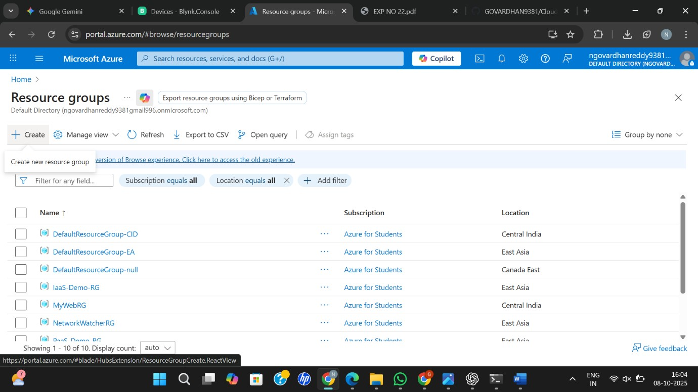

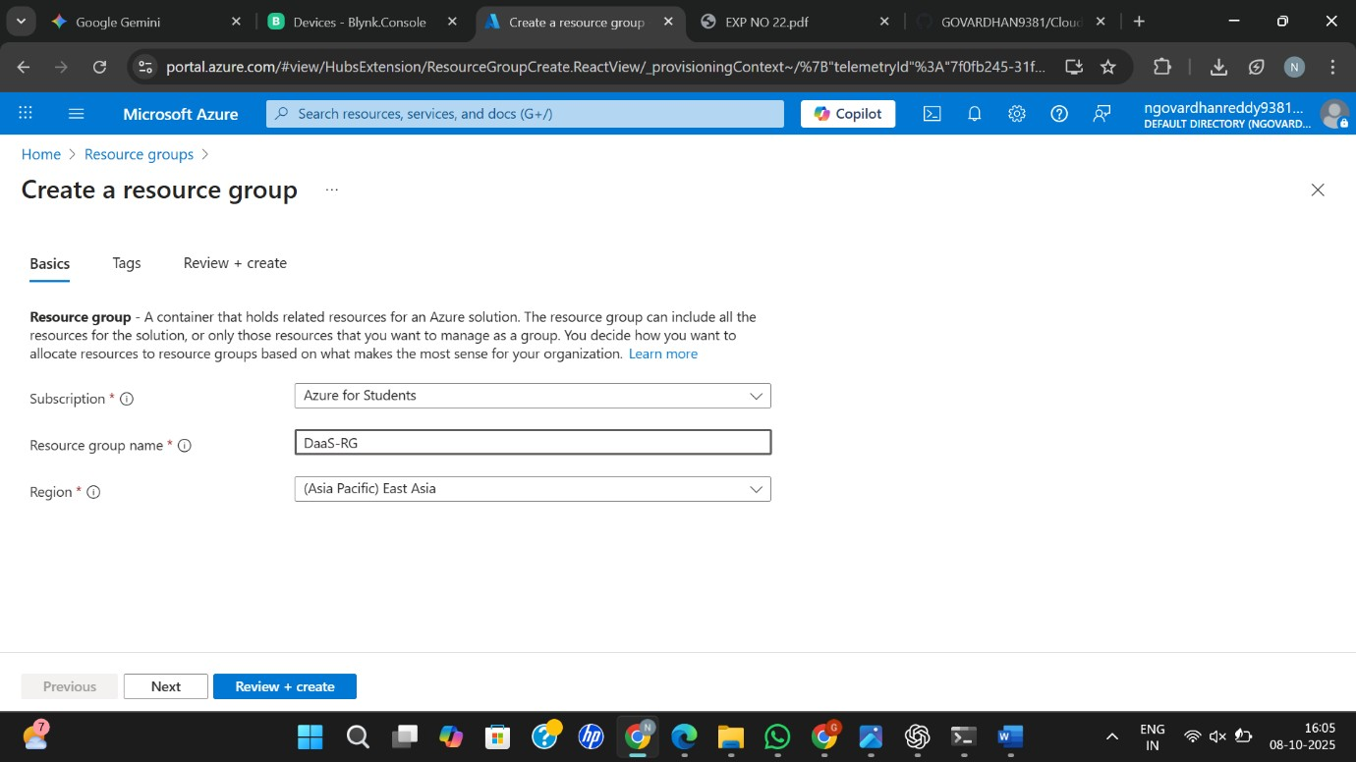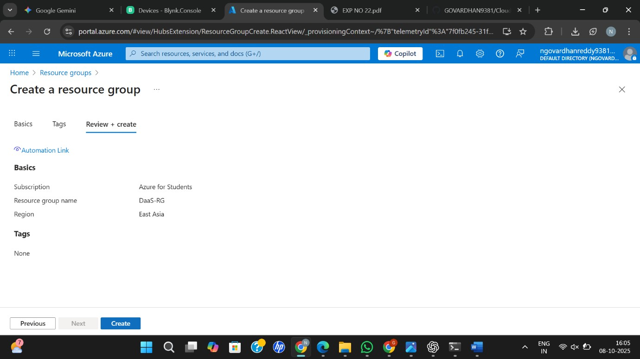
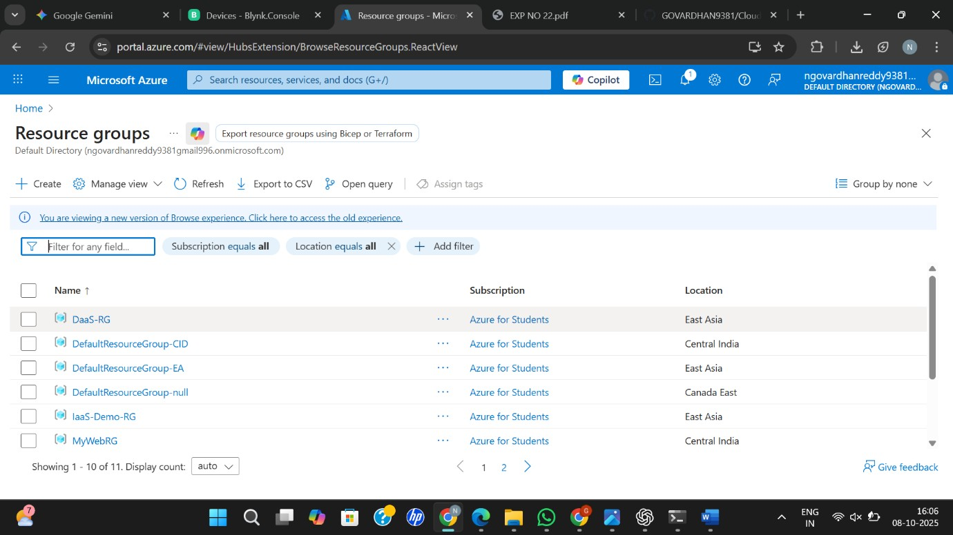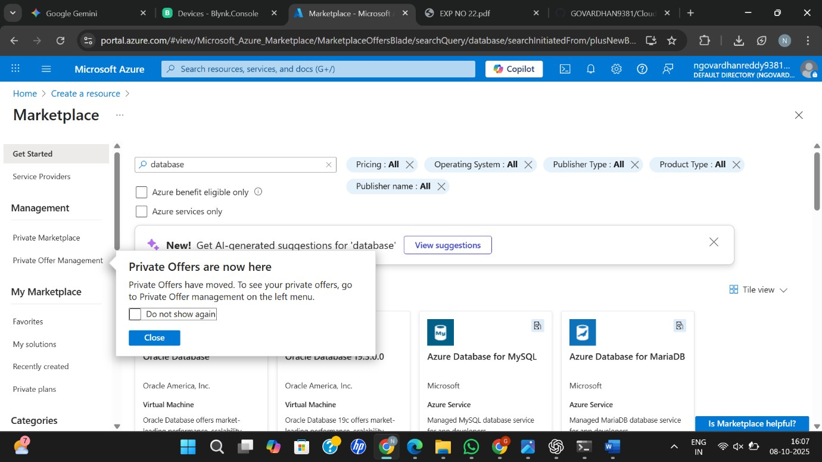
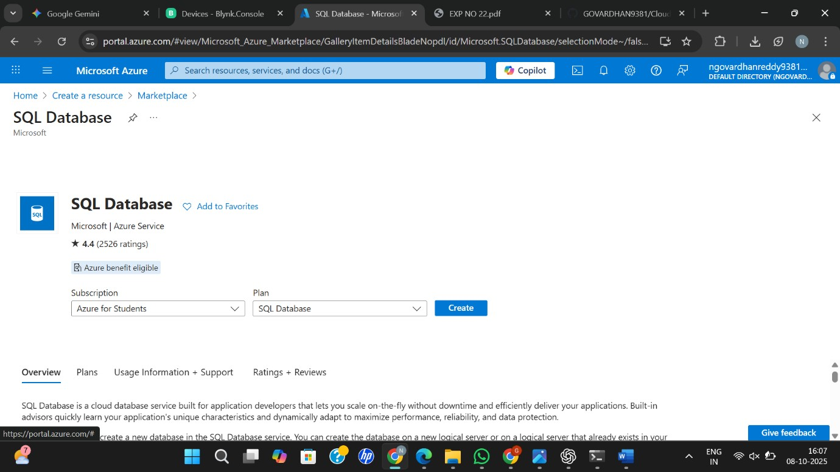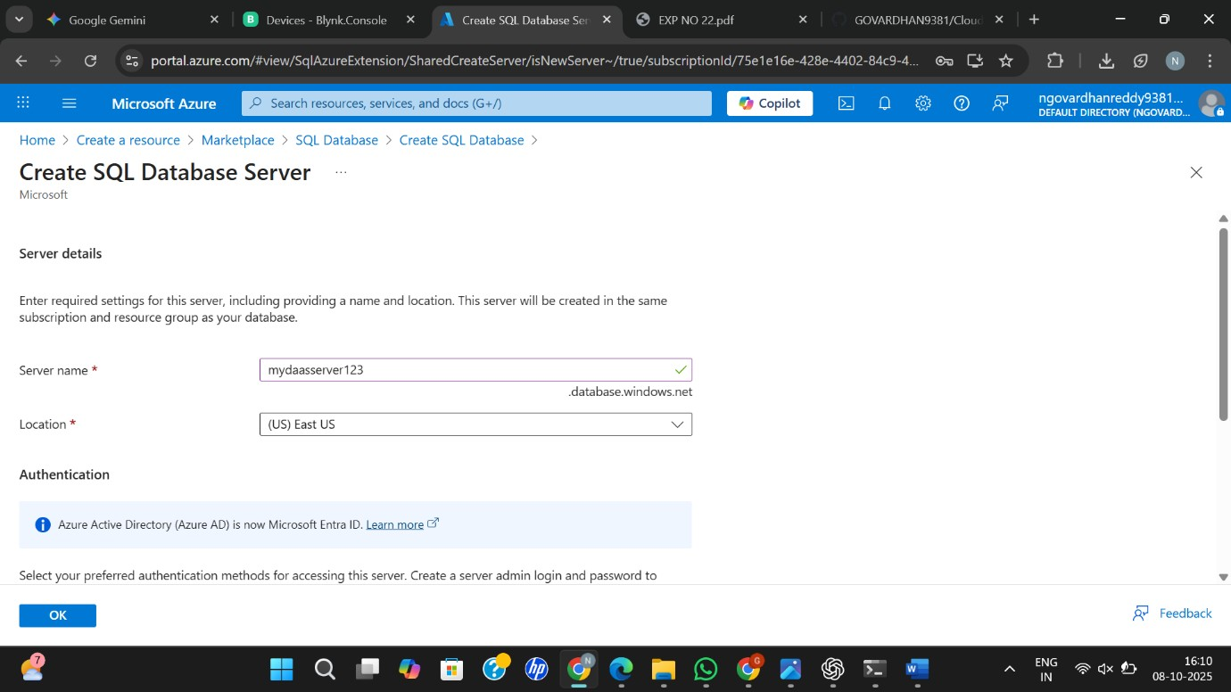

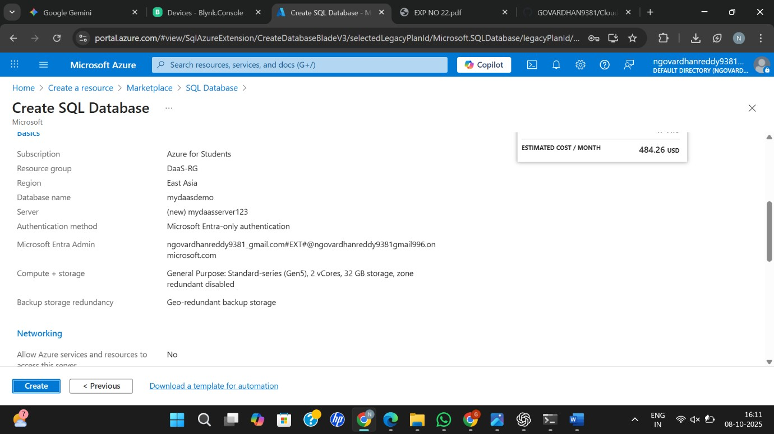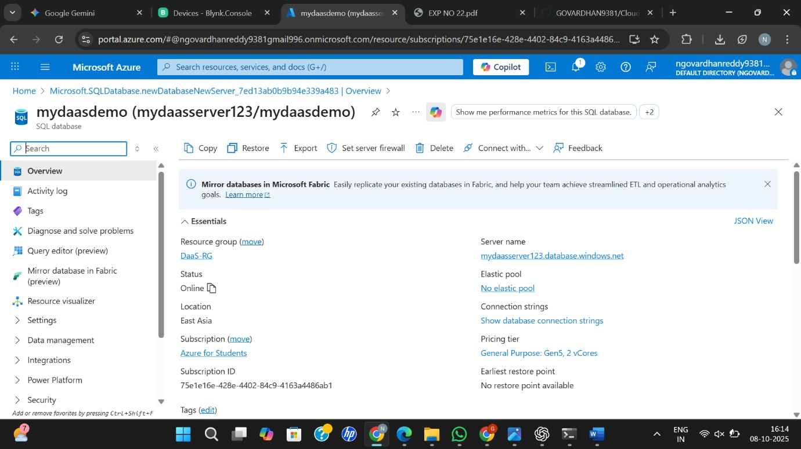

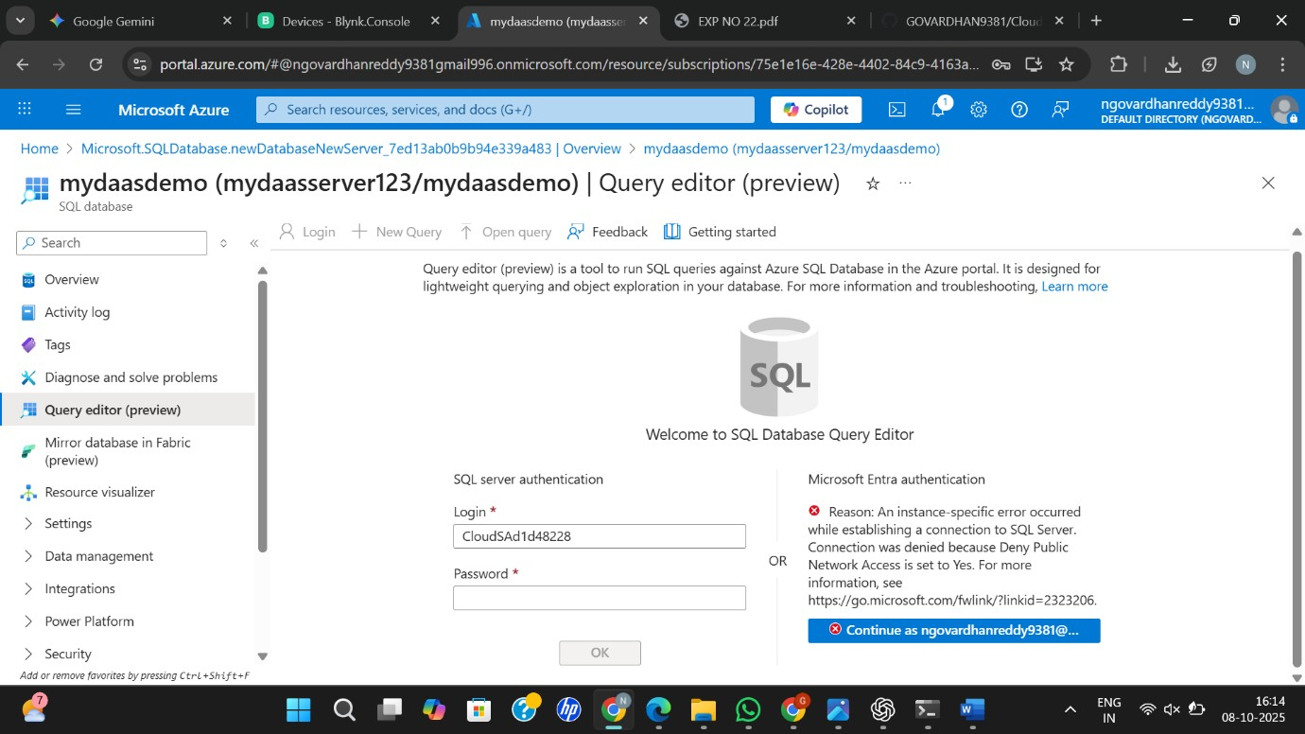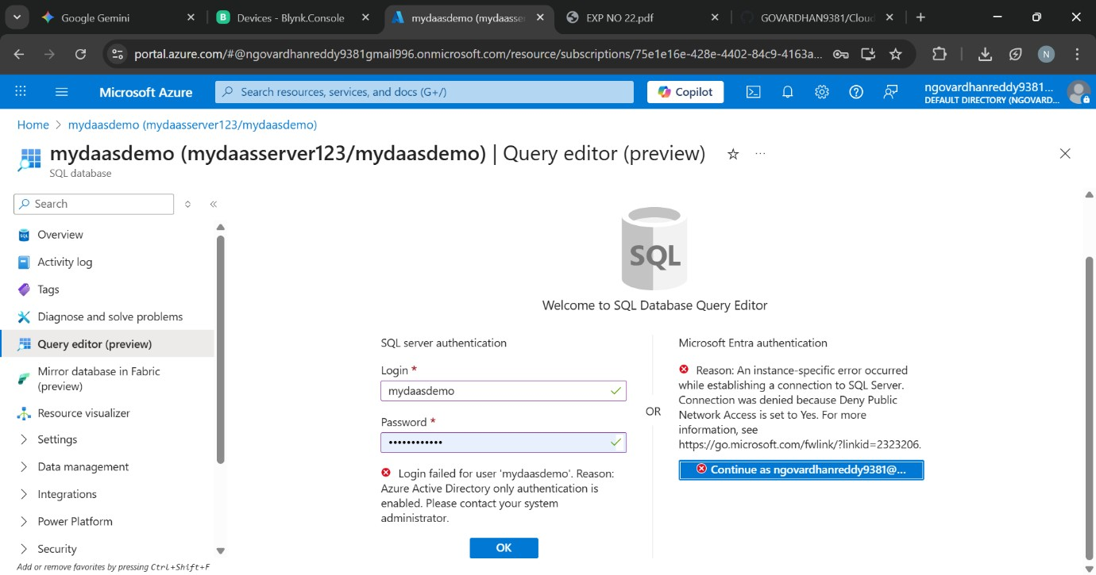
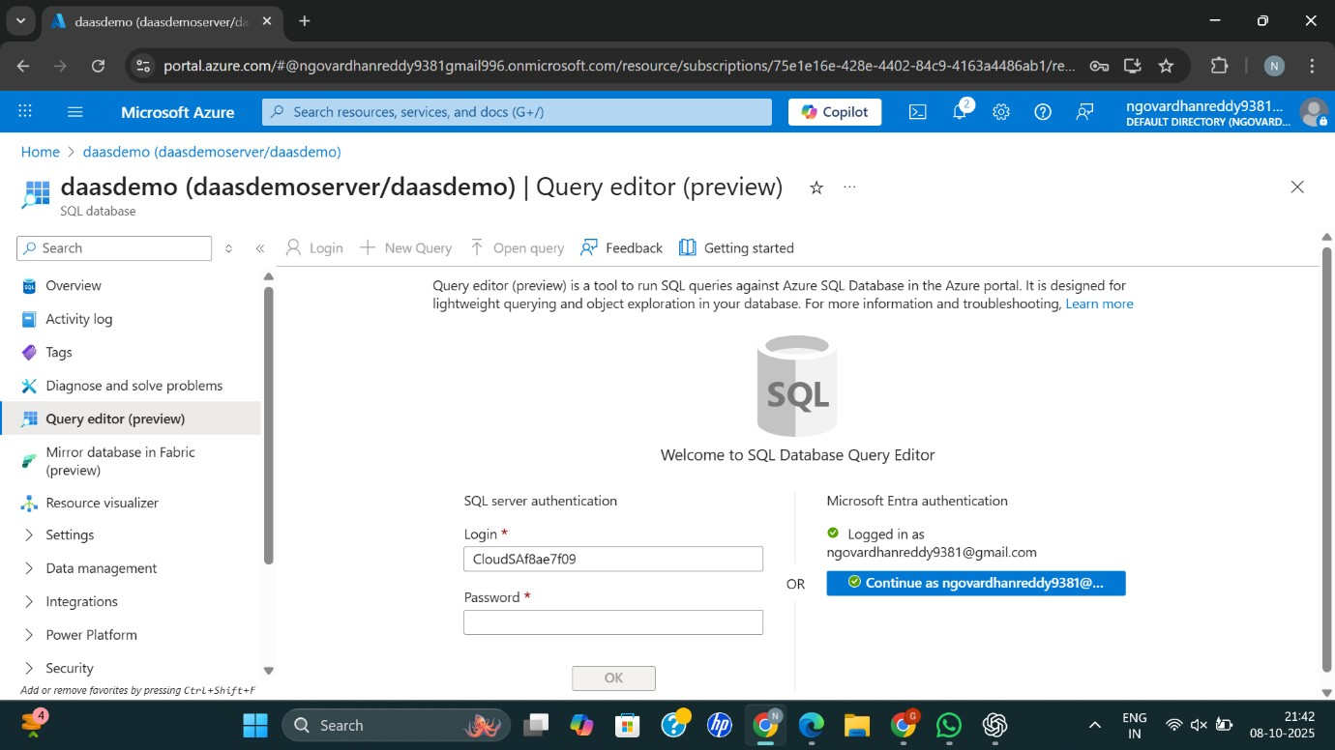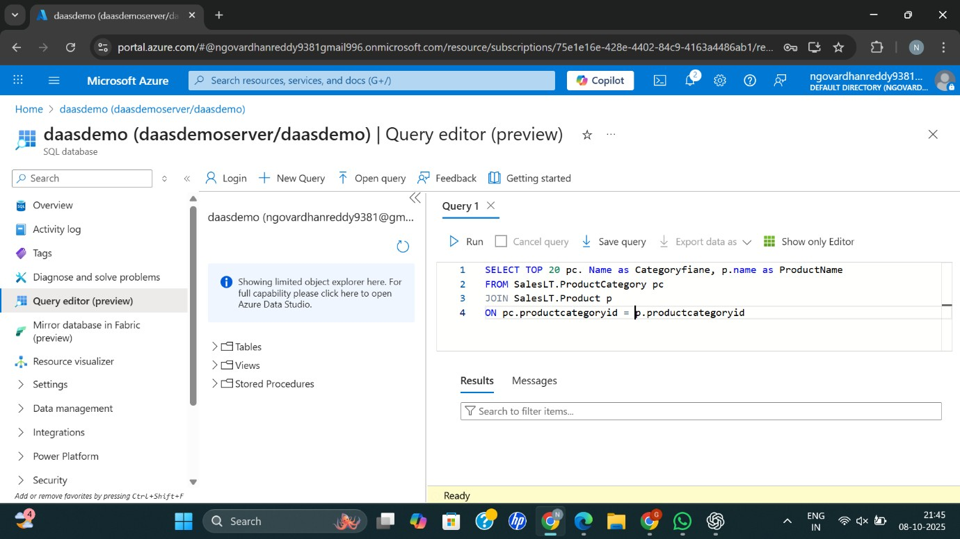

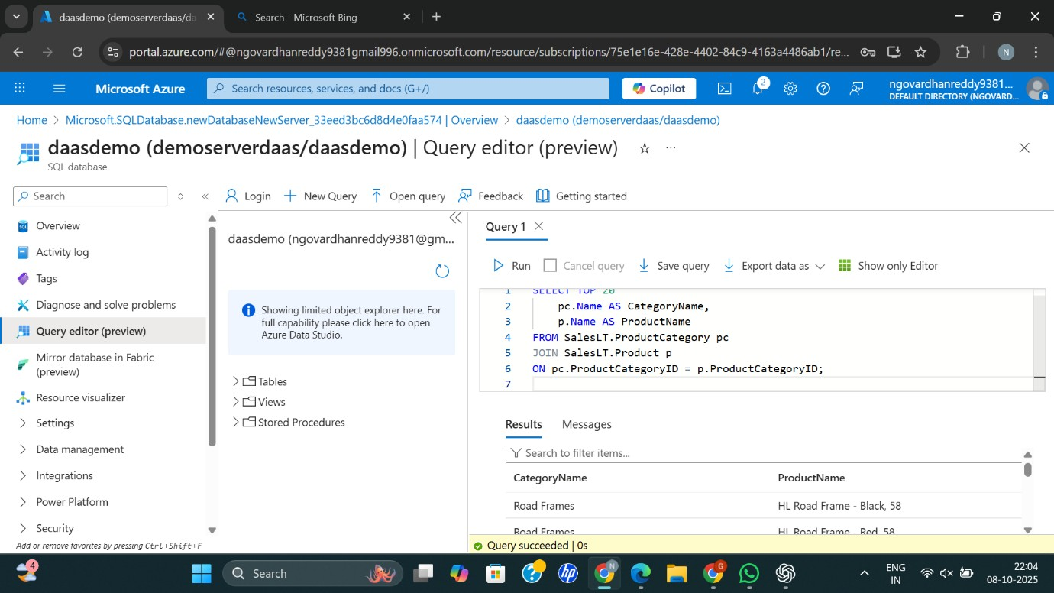
Result:
Successfully created and queried an Azure SQL Database using sample data — demonstrating Database as a Service (DaaS).

